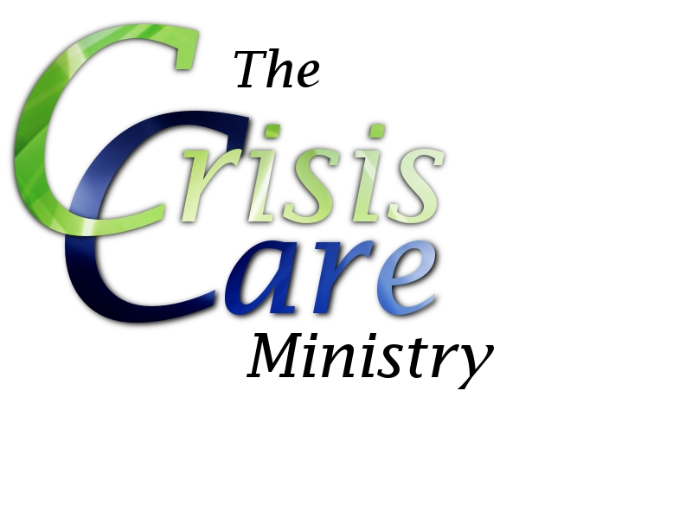

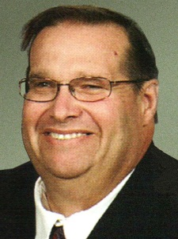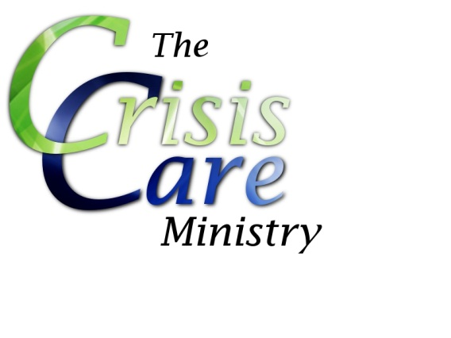

First United Methodist Church

Galesburg, IL

*Questions?*

Contact **Steve Fawer**

Crisis Care Coordinator

309-221-3370

or **Mary Runge**

Minister of Senior Adults

and Caring Ministries

309-342-3197

*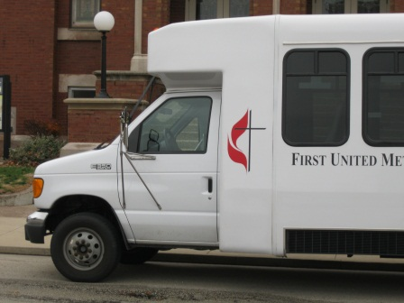C:\Users\Jake and Mary\AppData\Local\Microsoft\Windows\Temporary Internet Files\Content.IE5\Q64T56WR\MC900437944[1].wmfC:\Users\Jake and Mary\AppData\Local\Microsoft\Windows\Temporary Internet Files\Content.IE5\9VG8ANHP\MC900437942[1].wmfC:\Users\Jake and Mary\AppData\Local\Microsoft\Windows\Temporary Internet Files\Content.IE5\Q64T56WR\MC900437944[1].wmfC:\Users\Jake and Mary\AppData\Local\Microsoft\Windows\Temporary Internet Files\Content.IE5\RGMWNXNX\MC900437950[1].wmf*

*Providing Meals*

Crisis Care team members will provide meals for our church family facing various hardships, such as recovery following a hospital stay due to illness or surgery.

*Minor Repairs*

Crisis Care team members may provide light housekeeping and maintenance services on an as-needed basis for church family. In special circumstances, minor repairs may be provided. Housekeeping and maintenance that requires specialized knowledge or training (such as electrical or plumbing work) will not be provided.

The Crisis Care Ministry is a continuing effort by the First United Methodist Church of Galesburg, IL, to provide non-financial service and support to church family in times of crisis and to provide outreach opportunities for those seeking to serve as part of the Body of Christ. Opportunities for care and outreach include the following:

*Transportation*

We can provide assistance getting to and from the hospital or doctor’s office in personal vehicles. Bus transportation is also available for those who have attempted and are unable to schedule the city Handi-Van. Vehicles will not run trips for leisure or interpersonal appointments.

*So now I am giving you a new commandment: Love each other. Just as I have loved you, you should love each other.  Your love for one another will prove to the world that you are my disciples.*

*-John 13:34-35*

FUMC members in need of care or interested in being a care provider and team member of the Crisis Care ministry should contact Committee Chair **Steve Fawer** or **Mary Runge** (contact information listed on the back).

*Using and Providing Service*

*About*